RESOLUTION NO.__________

RE: CERTIFICATE OF APPROPRIATENESS UNDER THE
PROVISIONS OF THE ACT OF THE PENNSYLVANIA
LEGISLATURE 1961, JUNE 13, P.L. 282 (53
SECTION 8004) AND BETHLEHEM ORDINANCE NO.
3952 AS AMENDED.

WHEREAS, it is proposed to alter the approved plans for an addition to the front of the storefront at 10 W Fourth Street.

NOW, THEREFORE, BE IT RESOLVED by the Council of the City of Bethlehem that a Certificate of Appropriateness is hereby granted for the work.

Sponsored by: (s)

(s)

ADOPTED BY COUNCIL THIS DAY OF

(s)
President of Council

ATTEST:

(s)
City Clerk

HISTORIC CONSERVATION COMMISSION

CASE # 570– It is proposed to alter the approved plans for an addition to the front of the storefront at 10 W Fourth Street
OWNER/APPLICANT: Fred Rooney / Anthony Spagnola

The Commission upon motion by Mr. Evans seconded by Mr. Lousch adopted the proposal that City Council issue a Certificate of Appropriateness for the proposed work described herein:
- The proposal to alter the approved plans for an addition to the front of the storefront at 10 W Fourth Street was presented by Anthony Spagnola.
- The new plan will be to enclose the open porch area at the entrance to the storefront only.
- The new enclosure will be made of aluminum storefront and glass. There will be a pair of doors on the north façade and a single door to the east opening to the existing fabric awning covered patio.
- The design and details will match the entry storefront at Saxby’s and at Lupita.
- The storefront system will be in a grid and the doors will have 10 lights to match the door at Lupita.
- The aluminum storefront and doors will be black to match Saxby’s.
- The glass will be clear.
- A copy of the permit drawings should be submitted to the Historic Officer for review and as a record for the files.
- The proposed motion was unanimously approved.

CU: cu
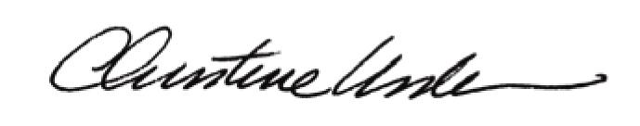

By:

Date of Meeting: November 16, 2015 Title: Historic Officer

